“I pledge my honor that I have abided by the Stevens Honor System” –cli50

Homework 5

9.41

a.

|  |  |  |
| --- | --- | --- |
| Field of Study | Right after H.S | Later |
| Trades | 320.28 | 621.72 |
| Design | 274.48 | 209.52 |
| Health | 2034 | 3051 |
| Media/IT | 975.88 | 2172.12 |
| Service | 486 | 864 |
| Other | 1172.6 | 1082.4 |

b.

The percentage of students that enrolled right after high school is 39.4%. The percentage of students that enrolled later high school is 60.6%. Over 50% of the students that enrolled later high school was studying trade, design, health, media/IT, and services. Compared to students right after H.S., there was only 1 section that had over 50% of the students enrolled which was other studies that were not mentioned on this survey.

c.

H0: There is no relationship between the field of study and when they enter the college

Ha: There is a relationship between the field of study and when they enter the college

X2 = = 275.93

df = (6-1)(2-1) = 5

P(x2> 275.93) = 0

Because the significant p-value is less than 0.05, we reject the null hypothesis. There is sufficient evidence to indicate that there is a relationship between the field of study and when they enter the college as this result is statistically significant.

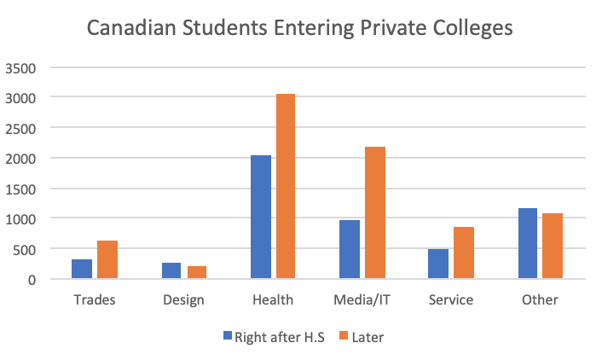

9.42

a.

|  |  |  |
| --- | --- | --- |
| Field of Study | Using Government Loans | Not using Government Loans |
| Trades | 424 | 518 |
| Design | 318 | 281 |
| Health | 2879 | 2355 |
| Media/IT | 1781 | 1457 |
| Service | 827 | 551 |
| Other | 1081 | 1219 |

b.

H0: The percent of students using government loans to finance their education does not vary with field of study

Ha: The percent of students using government loans to finance their education does vary with field of study

X2 = = 97.52

P(x2 > 97.52) = 0.0001

We reject the null hypothesis because the significant p-value is less than 0.05. Therefore, we know that the percent of students using government loans to finance their education does vary with the field of study.

c.

The significant p-value, 0.0001 is less than 0.05, therefore, the null hypothesis is rejected. There is sufficient evidence to indicate that the percent of students using government loans to finance their education does vary with field of study as this result is statistically significant.

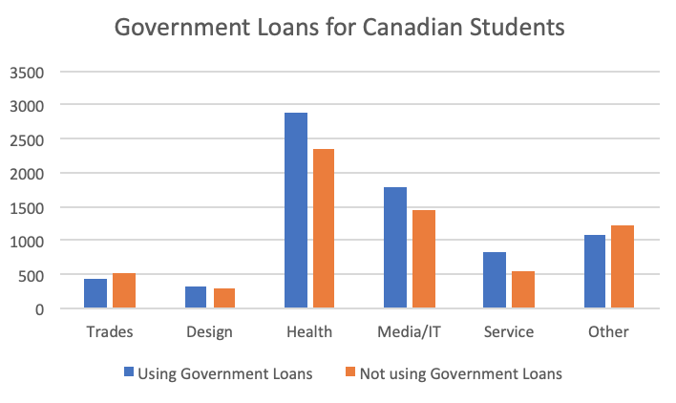

From the graph, we can conclude that the percent of students using government loans to finance their study like design, health, media/IT and service is higher than other studies such as trades and others.

d.

In 9.41, the total number was 13,364 students, but in 9.42, the total number was 13,691 students. A possible reason for this is because the government prefers to fund public colleges over private colleges since private colleges have their old funding.

9.43

a.

|  |  |  |
| --- | --- | --- |
| Field of Study | Using family | Not using family |
| Trades | 188 | 754 |
| Design | 221 | 378 |
| Health | 1360 | 3874 |
| Media/IT | 518 | 2720 |
| Service | 248 | 1130 |
| Other | 943 | 1357 |

b.

H0: There is no association between the government loans and the field of study

Ha: There is an association between the government loans and the field of study

X2 = = 543.98

= 0.05

P(x2>543.98) = 0.0001

Reject the null hypothesis because the significant p-value is less than 0.05. therefore, there is an association between the government loans and the field of study.

c.

The significant p-value, 0.0001 is less than 0.05, therefore, the null hypothesis is rejected. There is sufficient evidence to indicate that there is an association between the government loans and the field of study as this result is statistically significant.

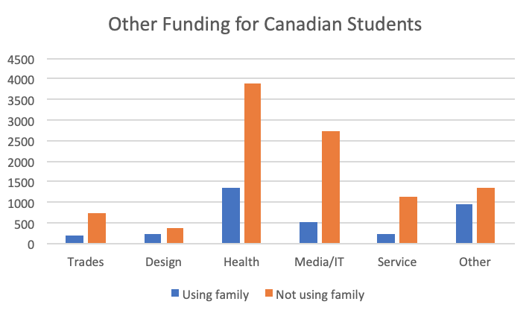

From the graph, we can see that most people choose to go to the Health and Media/IT fields. In addition, we can also see that students do not rely on their parents/family/spouse to fund college.

d.

In 9.41, the total number was 13,364 students, but in 9.43, the total number was 13,691 students. A possible reason for this is because students going to private college are taking out more loans as private colleges are typically more expensive then public colleges.